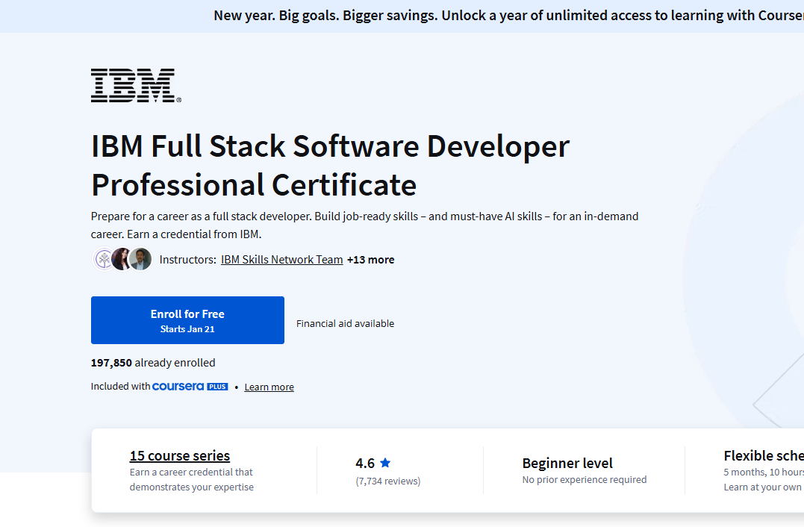

https://www.coursera.org/professional-certificates/ibm-full-stack-cloud-developer?msockid=2b68dc87fdbc6923114fc9d6fc7e68e5

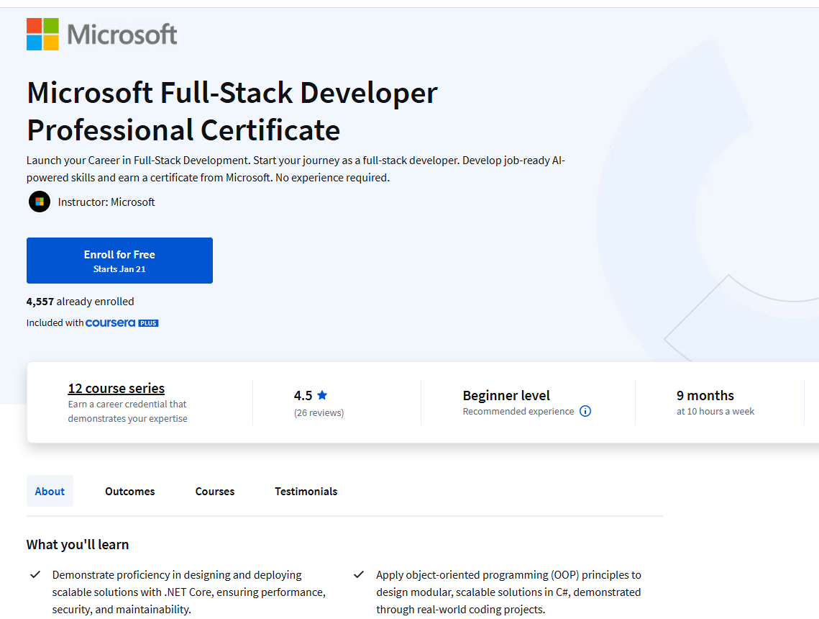

https://www.coursera.org/professional-certificates/microsoft-full-stack-developer/paidmedia?action=enroll&adgroup=b2c_emea_microsoft-full-stack-developer_microsoft_px_bau_bg_s1_x_x_nb-mx_x_hyb_x_x_x&adgroup=b2c_emea_microsoft-full-stack-developer_microsoft_px_bau_bg_s1_x_x_nb-mx_x_hyb_x_x_x&adgroupid=1252345077659161&adgroupid=1252345077659161&adposition=&adposition=&bidmatchtype=bp&bidmatchtype=bp&campaignid=662926088&campaignid=662926088&creativeid=78271697135546&creativeid=78271697135546&device=c&device=c&devicemodel=&devicemodel=&extensionid=&extensionid=&keyword=full+stack+developer+certification&keyword=full+stack+developer+certification&matchtype=p&matchtype=p&msclkid=8a6b54597b8f18d1217e33d68cbe6d39&msclkid=8a6b54597b8f18d1217e33d68cbe6d39&network=o&network=o&querystring=level+5+full+stack+developers+course&querystring=level+5+full+stack+developers+course&targetid=kwd-78271936700527%3Aloc-188&targetid=kwd-78271936700527%3Aloc-188&utm_campaign=b2c_emea_microsoft-full-stack-developer_microsoft_ftcof_professional-certificates_px_dr_bau_bg_sem_pr_s1_en_m_x_x_x&utm_campaign=b2c_emea_microsoft-full-stack-developer_microsoft_ftcof_professional-certificates_px_dr_bau_bg_sem_pr_s1_en_m_x_x_x&utm_content=b2c_emea_microsoft-full-stack-developer_microsoft_px_bau_bg_s1_x_x_nb-mx_x_hyb_x_x_x&utm_content=b2c_emea_microsoft-full-stack-developer_microsoft_px_bau_bg_s1_x_x_nb-mx_x_hyb_x_x_x&utm_medium=sem&utm_medium=sem&utm_source=bg&utm_source=bg&utm_term=full+stack+developer+certification&utm_term=full+stack+developer+certification

